November Editorial
_______________________________________________ ____________________
Dear friends of ADMA,
As every month we come to you through ADMA online, the tool that has helped us feel connected and close for a long time. This is what we strongly desire - to grow in communion. Communion in local realities, in communities, among all ADMA groups in the world, in the Salesian Family, in the Universal Church!
Pope Francis has called the next Synod, which opened in October, precisely on this theme, inviting the Church to question itself on a theme which is decisive for its life and mission: "The path of synodality is the path that God expects from the Church in the third millennium. "
Communion, participation and mission. We too as an association want to be present and participate more and more in the future. The Primary ADMA of Valdocco, has a role of animation that embraces all the realities of the world and all of you in the groups at the local level. You all participate in this animation, and you are part of that splendid chain of radiation that reaches out from Mary's house to our homes all over the world.
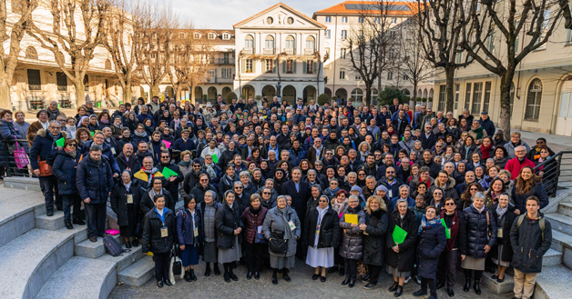
It is precisely in this perspective that we want today to share with you our great joy at the renewal of the Primary ADMA council in Valdocco which took place on 24 October 2021 on the occasion of the 31st Marian Day.
First of all, we want to share our gratitude for those who have offered their service to Mary in these last four years during which they have worked, served, prayed, and hoped in a spirit of communion for the good of our association, to try to love Mary more and to bring our love for Mary to more people. May God bless their efforts and fill them with grace.
We also want to thank all the new councillors for their yes to Mary. We want to welcome them warmly and accompany them with prayer. We ask Mary to guide the steps of the new council, their directives, choices, and projects so that everything may be for the greater glory of her son Jesus.
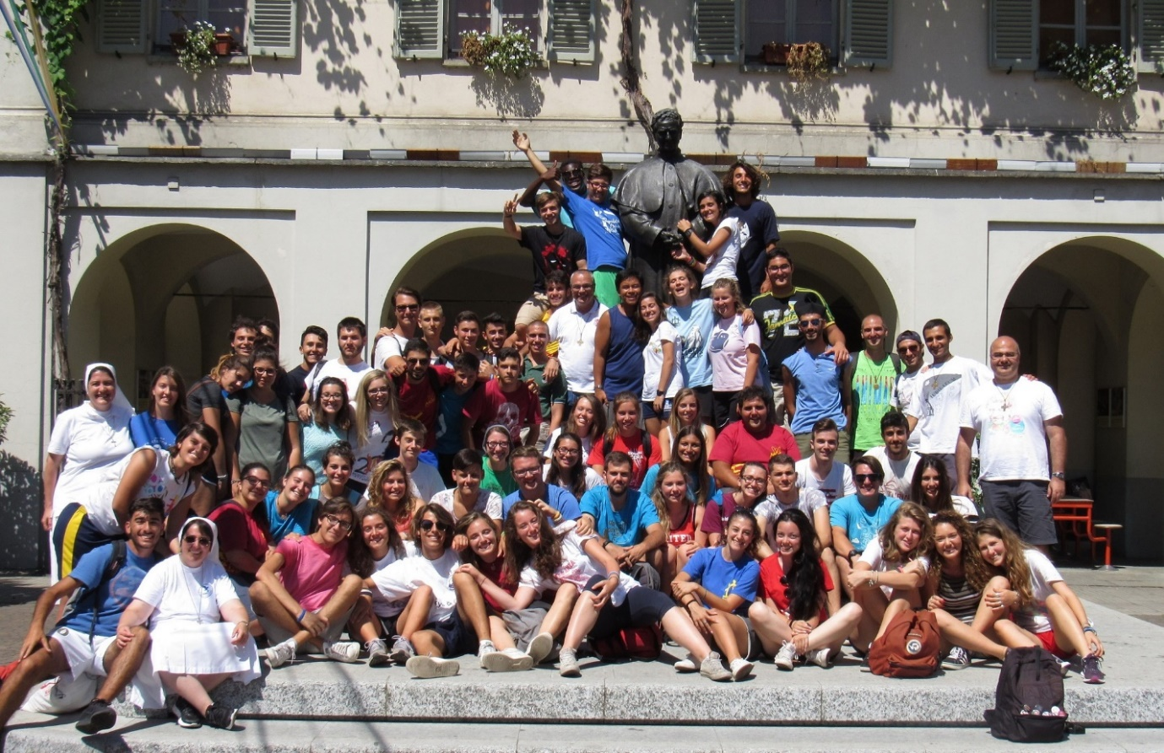
We pray that the new council - as the Rector Major's new Strenna suggests – may do everything out of love and nothing by force and that all of us, in our groups, in our homes, in our journeys can also remind ourselves that nothing makes sense if not in charity and love for our brothers and sisters.
Renato Valera, President ADMA Valdocco.
Alejandro Guevara, Spiritual Animator ADMA Valdocco.

FORMATION PROGRAMME 2021-2022
Family love, vocation and a life of holiness

THE VOCATION OF THE FAMILY

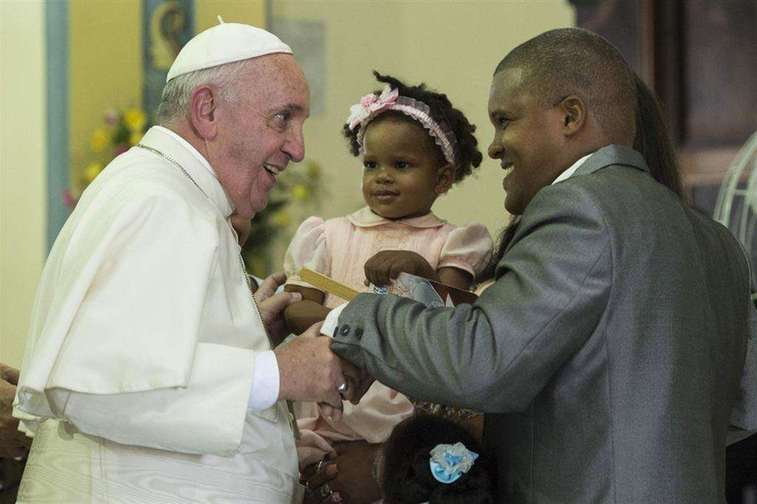
If we turn our gaze to Jesus, we understand the vocation of the family. The very fact that he chose "a mother in order to become a man and a family to grow and mature as such" is very clear. The incarnation takes place through the birth of Jesus as a human being, and within a family. Jesus could have chosen to appear as an adult and begin his public ministry immediately. Instead, the path of the incarnation passes through the Annunciation, Mary's pregnancy, childbirth ... and 30 years of ordinary, humble, hidden life in Nazareth, where Jesus learned to live by his work and to enjoy simple affections. in the heart of his family, inserted in the life of the village and the synagogue. This is very important: the incarnation is not a fable, but a reality. God "forced" himself to become like us, through all the stages of growth of a human person. And he went further, to experience rejection, condemnation, even death on the cross.
The Church's teaching on marriage and the family draws its strength from this fact: God's decision to walk with us, in everything. Therefore, it is not a question of static rules but of a lifestyle, in the light of the infinite love of the Father.

Jesus restores God's plan and brings it to fulfilment. Marriage is in fact a gift from God and Jesus invites us to take care of it. The union of love of man and woman and the indissolubility of marriage are part of this gift, in deep and mutual respect of the two spouses. From the plan of creation, it is clear beyond any doubt that marriage is the union of a man and a woman. Any other type of union, therefore, cannot even be compared to what happens in natural and Christian marriage. What the ideology of gender tries to convey to us is "ideology", in fact, and dangerous! While it is very important to protect and respect minorities, one cannot transform the minority (in this case, people with sexual identity problems) into normality and change the whole way of seeing the world, because there is a minority that sees it differently.

The full meaning of the marriage covenant is revealed in Christ and in the Church. In particular, St. Paul makes use of the analogy with marriage to explain the profound union of Christ with the Church (cf. Eph 5: 21-33). In doing so, he reveals the stupendous and unexpected depth of the sacrament, which has as its model the relationship and love of Christ for his Church. Indeed, who among us would not want to "be submissive" to someone who loves him or her as Christ loves the Church? We do not normally like the fact of "being submissive", but it is a matter of being submissive to Christ himself, who never looks down on us. He places himself on our level, for example, during the washing of the feet (cf. Jn 13, 1-20), Jesus places himself beneath us and looks at us from below! This is our God! He reigns by lowering himself and becoming the servant of all.

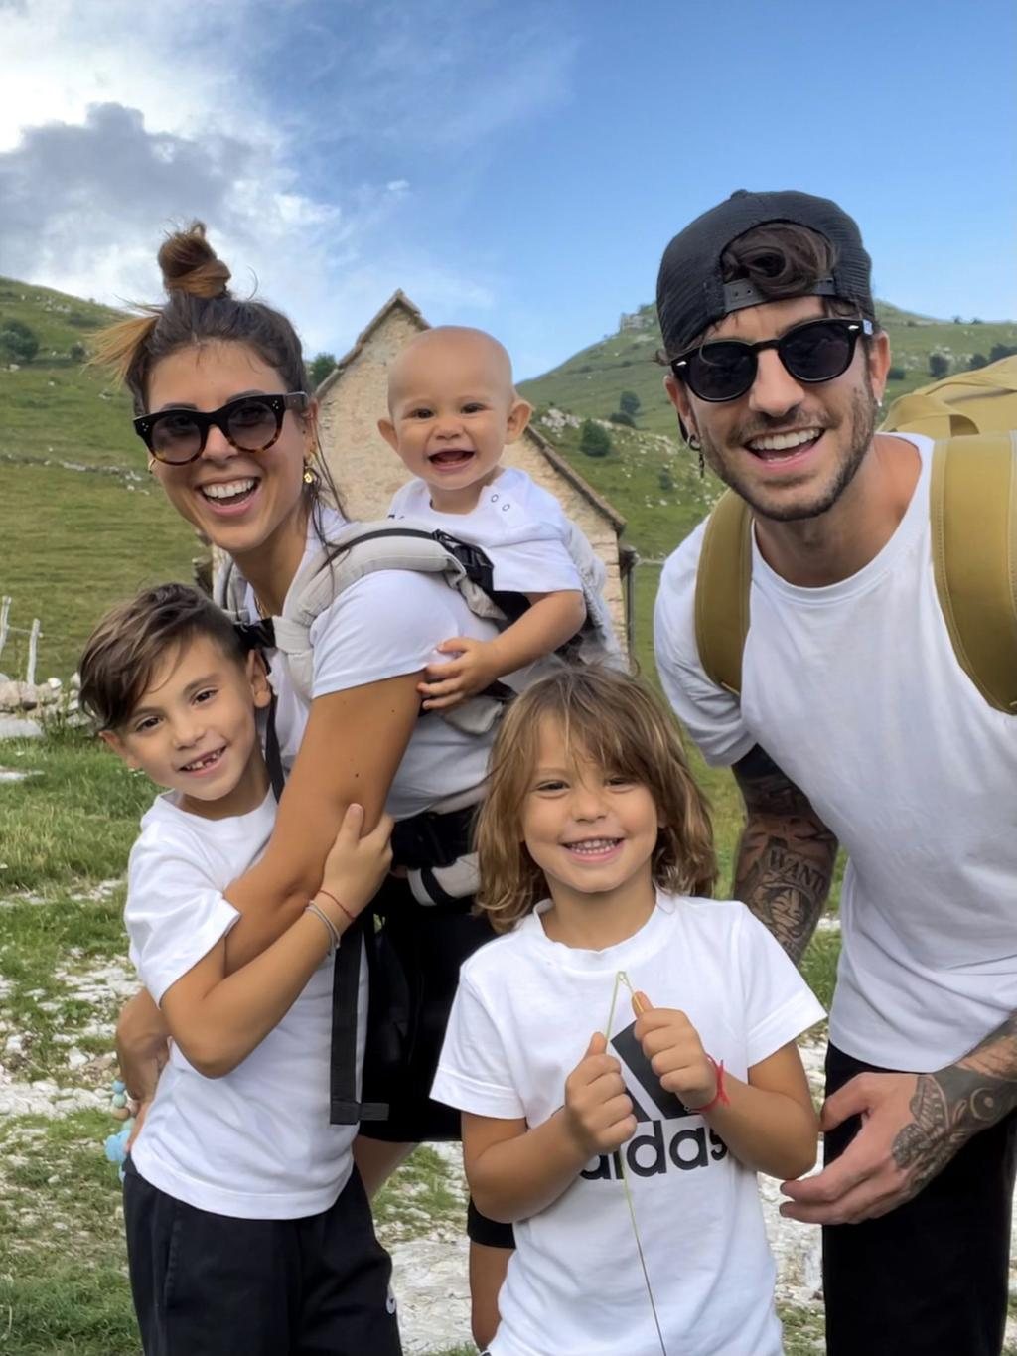
The teaching to be found in the documents of the Church reminds us that love is at the centre of marriage: the love of Christ for us which is symbolized and lived by the love between husband and wife, who give themselves to each other reciprocally. Jesus takes on human love, purifies it and brings it to fullness. So, notice: our task is not to live human love in a way that is equal to divine love. We will never succeed! Rather, it is a question of realizing and believing that Christ raised human love through his love for the Church, which is signified in the sacrament of marriage. Thus, the spouses are consecrated in the sacrament and build up the body of the Church. The Church, therefore, looks to the Christian family to fully understand its mystery. The sacrament is a gift for the sanctification and salvation of the spouses: it is a real vocation that must pass through the process of discernment, like every vocation. This is true both for the initial decision that the spouses make regarding this choice of life, and for continuing to grow constantly within this dynamic choice. Without constant discernment, it is not possible to live Christian marriage and the family life that flows from it.

In this context, the sexual union of the two spouses, lived in a human way and sanctified by the sacrament, becomes a way of growth in the life of grace. The "nuptial mystery" consists also in this. Thus, in this way, sexuality is freed from any ambiguity and becomes the road to sanctification. This is far from believing that the sexual act, even in marriage, remains at least a "venial sin"! We now hold the polar opposite of this vision of some thinkers of the early centuries of Christianity. Even if human actions can hardly be completely free from any form of selfishness, the sacrament with its grace sanctifies everything that is part of marriage and helps it to pursue its two ends: the communion of spouses, in a path of mutual help towards holiness, and openness to procreation. These ends are both important, to the point that even a marriage where procreation is not possible remains sacramentally valid, because of the other end.

The spouses are the ministers of the sacrament of marriage. In fact, in Baptism their ability to unite in marriage was consecrated. The instruments of God's action that makes them one flesh are their consent and the union of their bodies.

Even those who live this reality imperfectly (those who have contracted a civil marriage, those who simply live together, the divorced and remarried…) are followed with love by the Church. Every difficult situation must be considered as a particular case and, while the truth of the Gospel and the doctrine of the Church must be expressed clearly, judgments that do not take into account the complexity of different situations must be avoided.

Within this vision, the integral education of children is a very serious duty and at the same time a primary right of parents: an essential and irreplaceable right that they are called to defend and that no one should take away from them. The school - state or private - does not replace parents but complements their action. And this is true on both sides. Woe if the school wants to replace the parents and woe to those parents who delude themselves into "parking" their children at school and think they have solved the "problem" of their education.
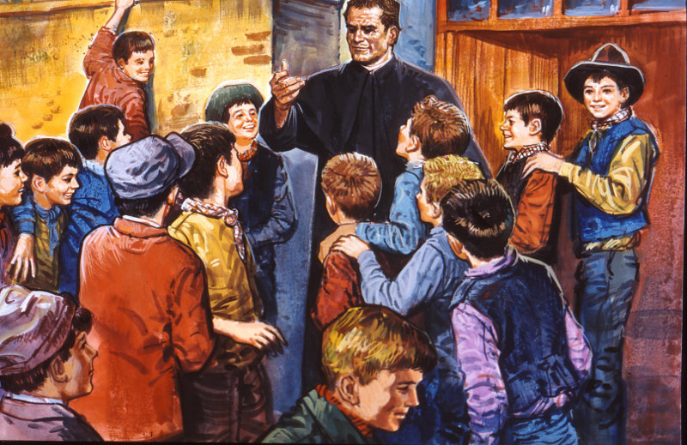
The first experience of Church - of communion between persons - takes place and matures in the family. In the family we learn the struggle and the joy of work, brotherly love, generous forgiveness and both personal and liturgical prayer. Furthermore, the Church also grows through the unitive love of so many spouses who live the sacrament of marriage with commitment: their union makes the whole Church an expression and reality of communion.

Without the vocation of the family, sanctified and strengthened by the sacrament of marriage, the Church would not be the spouse and body of Christ, to the extent that she is called to be so by the Father's plan for the building of his kingdom.

In the Salesian Family, the "family spirit" is an essential element for living according to Don Bosco's style. In particular, the ability to welcome everyone is emphasized, making them feel responsible for the common good. The atmosphere that is created is one of mutual confidence and daily forgiveness, in which one wishes to share everything with joy. There is therefore no need, ordinarily, to have recourse to rules, but rather to the movement of the heart and faith. This is a witness that enkindles in the young the desire to get to know and follow the Salesian vocation, each according to the state of life that suits him or her best. (cf. SDB constitutions art. 16).

GETTING TO KNOW EACH OTHER Chronicle GC24 FMA

24th General Chapter of the FMA Institute: an experience of faith and a school of formation for the celebration of the 150th anniversary of the Foundation.

The 24th General Chapter was a cenacle of charismatic vitality, an expression of the "time of God", a time of listening and of courageous choices.

The theme was "Do whatever he tells you" (Jn 2,5.). Communities that generate life in the heart of the present time", guided the experience of the Chapter which was held from 12 September to 24 October 2021. It involved the 174 Chapter members in fraternal life and in reflection/study, in prayer, and in listening/discussion.

There were three powerful moments in the development of GC 24. The first was the report of the six-year period 2014-2020, presented by Mother Yvonne Reungoat and the General Councilors. From this information emerged evidence of communion between educating communities to live Generativity in the diversity of forces, presences, processes through which networks of listening, fraternal mission, missionary audacity and apostolic passion are intertwined.

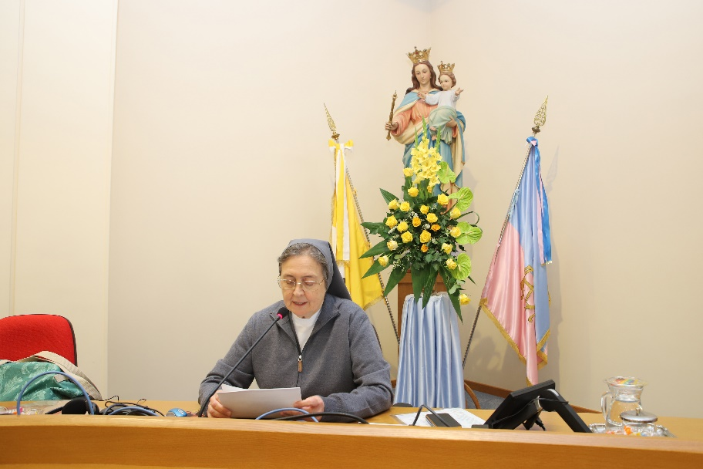
A second important moment was the election of Sister Chiara Cazzuola as the tenth successor of Mother Mazzarello, for the six years 2021-2027.

The third major event was on 22 October when Pope Francis met the participants in the Chapter at the Generalate of the FMA. Among other things, he urged us to continue working with other Congregations, trying to live relationships of reciprocity and co-responsibility, bearing witness to a concrete way of living synodality, with an openness to the "Novelties and Surprises" of the Holy Spirit.

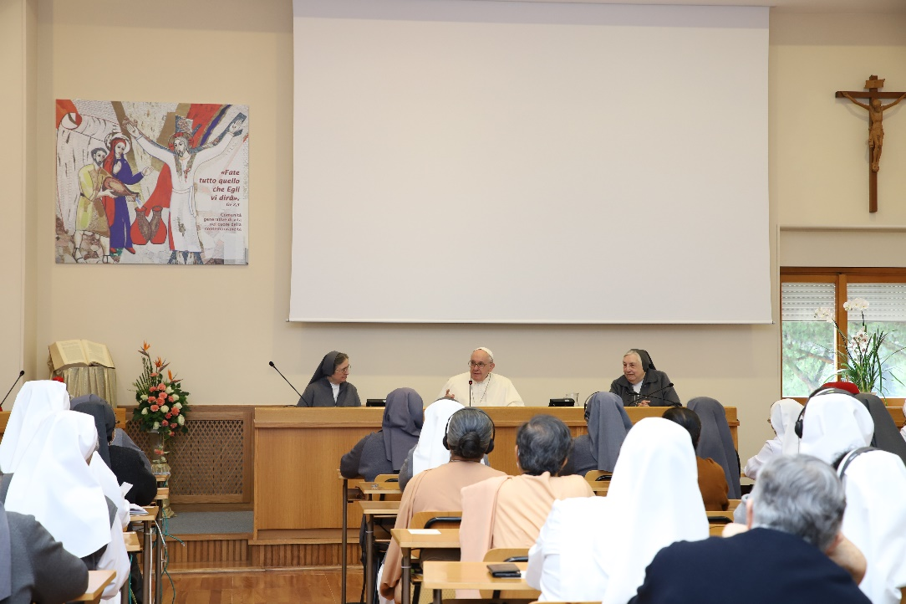
On 24 October, Mother General Chiara Cazzuola presented her concluding speech to the Chapter members. Among other things she said: "GC24 will be fruitful for the whole Institute if we are effective mediations of communication sharing this profound experi-ence that we have enjoyed and celebrated together. It is time then to go down from Cana to Capernaum, not alone, but with Jesus and Mary, to share life and mission together with the young people and the laity, to let God breathe in our existence and courageously face the challenges we will encounter. We entrust ourselves to Mary to help us to be women who know how to bring the new wine of hope in our history marked by so many sufferings and hardships but blessed by the sweet Providence of the Father.”

The Chapter members, as a Generative Community enlightened by the presence of Mary Most Holy, focused on three significant choices: to be in continuous formation, to walk in synodality, and to network with a view to integral ecology - three actions whose leitmotif is the quality of presence, that is, “being there” as people and as a community in the heart of present-day life..

Mary Help of Christians, who is present in all the houses of the Institute, will help the FMA not to forget the grace of their origins, the humility and smallness of the beginnings that made God's Action transparent in the life and message of so many sisters.
REGULATIONS

REGULATIONS OF THE ASSOCIATION OF MARY HELP OF CHRISTIANS

FOR STUDY AND IMPLEMENTATION

TO HELP US TO REALIZE OUR IDENTITY

ARTICLE 5 – SHARING IN SPIRITUAL BENEFITS (PART ONE)

The members share in the indulgences and spiritual benefits proper to the association and in those of the Salesian Family. An Indulgence is defined as follows by the Code of Canon Law and in the Catechism of the Catholic Church: "An indulgence is the remission in the sight of God of the temporal punishment due for sins, the guilt of which has already been forgiven. A member of Christ’s faithful who is properly disposed and who fulfils certain specific conditions may gain an indulgence by the help of the church, which, as the minister of redemption, authoritatively dispenses and applies the treasury of the merits of Christ and the saints.” The gift of Indulgence manifests the fullness of God's mercy, which is expressed primarily in the sacrament of Penance and Reconciliation.

In general, the acquiring of Indulgences requires certain conditions and the fulfilment of certain works. To obtain indulgences, both plenary and partial, the faithful must be in a state of grace. A plenary indulgence can be obtained only once a day and it is necessary that the faithful:
- has the interior disposition of complete detachment from sin, even if venial; - confess one’s sins sacramentally sins; - receive the Holy Eucharist; - pray according to the intentions of the Pope.
Indulgences are always applicable to oneself or to the souls of the dead, but they are not applicable to other people living on earth.

Members of the Association can obtain a Plenary Indulgence by renewing the promise to faithfully observe the Regulations of the Association at the following times of the year: - Day of admission - Feast of St. Francis de Sales on January 24 - Feast of St John Bosco on January 31 - Feast of Annunciation on March 25 - Feast of Mary Help of Christians on May 24 - Feast of Visitation on May 31 - Feast of Assumption on August 15 - Feast of Nativity on September 8 - Feast of Immaculate Conception on 8 December - Feast of Nativity of the Lord on December 25.

Andrea and Maria Adele Damiani
FAMILY CHRONICLE
- https://www.infoans.org/sezioni/foto-notizie/item/14032-vietnam-costituito-un-gruppo-adma-al-don-bosco-cat-dam

- https://www.infoans.org/sezioni/notizie/item/13978-italia-crescere-nella-comunione-la-xxxi-giornata-mariana-dell-adma-a-torino

- https://www.infoans.org/sezioni/foto-notizie/item/13948-portogallo-xxxv-pellegrinaggio-della-famiglia-salesiana-a-mogofores

- https://www.infoans.org/sezioni/notizie/item/13906-rmg-primo-incontro-online-dei-delegati-ispettoriali-per-la-famiglia-salesiana-del-mondo

