OUR LADY OF THE ROSARY
Dear friends,
Each year in October, the memorial of Our Lady of the Rosary is celebrated. This gives us the opportunity to share some reflections on this prayer so dear to all of us and loved and prayed by all of us. I refer to Saint John Paul II and Don Bosco.
The Rosary of the Blessed Virgin Mary is a prayer dear to many Saints and encouraged by the Magisterium of the Church. In its simplicity and depth, it remains today a prayer of great significance, destined to produce fruits of holiness. The Rosary, although distinguished by its Marian character, is a prayer centred on Christ. In the sobriety of its parts, it contains the depth of the whole Gospel message, of which it is like a compendium. It re-echoes the prayer of Mary, her perennial Magnificat for the work of the Incarnation. Through it, the Christian people learn from Mary to contemplate the beauty of Christ's face and to experience the depth of his love. Through the Rosary, each of us receives abundant graces from the hands of the Mother of our Redeemer.
Among recent Popes who were distinguished for promoting the Rosary, we remember St. John XXIII, Paul VI, who in the Apostolic Exhortation "Marialis cultus" in line with the inspiration of the Second Vatican Council, underlined the evangelical character of the Rosary and its Christological orientation, and St. John Paul II who added the luminous mysteries in his Apostolic Letter "Rosarium Virginis Mariae." As we can see, the promotion of the prayer of the Rosary bears fruits of holiness and it cannot be otherwise. Anyone who prays the Rosary approaches Mary, and by doing so approaches God.
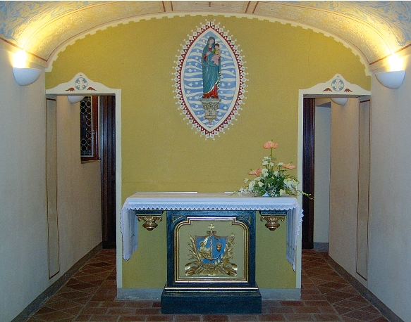
Don Bosco loved the rosary so much that he wanted it to be recited every day. He said: "The rosary is as necessary for life as daily bread" (cf. MB 1, 90). This prayer was one of the great lessons he received from Mamma Margaret. In the Memoirs of the Oratory, he recalls: "When I was still very young, my mother taught me my first prayers. As soon as I was able to join my brothers, she made me kneel with them in the morning and in the evening: we said the prayers together and the third part of the rosary."
Mamma Margaret excelled as a teacher of prayer, a prayer that was recited in the family. Having learned it from his mother, John Bosco was not ashamed to have his friends pray the rosary. He combined prayer and catechesis with games and fun. This was the prelude to the educational style that would lead him to become a pastor of the young.
It is good to remember that in the Becchi, on the ground floor of his brother Joseph’s house, a small room was converted into a chapel and Don Bosco dedicated it to Our Lady of the Rosary. He inaugurated this small chapel on 8 October 1848. Until 1869, the Saint celebrated the Feast of Our Lady of the Rosary there every year, solemnizing it with the presence of the Valdocco band and the boys’ choir.
This place was Don Bosco’s first centre of Marian devotion and played a privileged part in the origins of the Salesian Congregation. In fact, it was here that Michael Rua and Joseph Rocchietti received the clerical habit on 3 October 1852. Dominic Savio probably also prayed in this chapel, on the occasion of his first meeting with Don Bosco on 2 October 1854, and in the following two years during the autumn holidays at the Becchi. Many moments in Don Bosco's life were marked by the prayer of the Rosary: ​​we read in the Memoirs of the Oratory the conclusion of the stage of the itinerant oratory. We also remember that once a year in the chapel, on All Saints' evening, the entire Rosary was recited in suffrage for the souls in Purgatory, and Don Bosco did not fail to participate, kneeling in the sanctuary and often leading the prayer himself." (cf. MB III 16).
The great missionary enterprise that the Salesians launched throughout the world is also marked by the recital of the Rosary, as Don Bosco saw in a missionary dream: "I saw our Missionaries advancing towards those hordes of savages; the missionaries instructed them, and they listened willingly. They were well taught, and they learned well. They were admonished and accepted and put into practice the advice they received. I stopped and I noticed that the missionaries were praying the Holy Rosary, while the savages, running from all sides, made way for them to pass and answered the prayer in unison."(MB X 55).
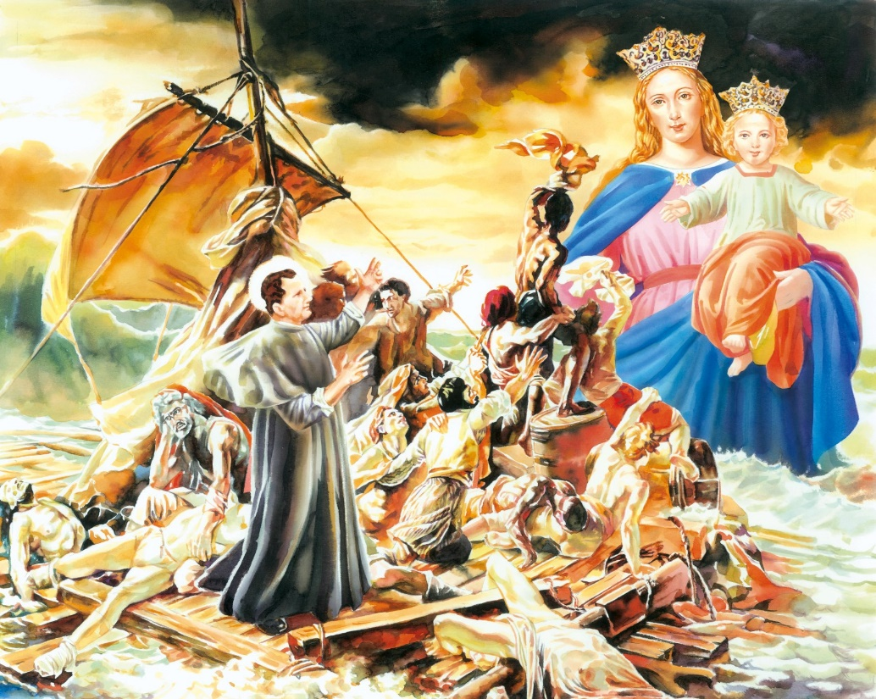
The Rosary and the mission are so closely linked that this month the Church celebrates the missionary spirit which is a constituent element of our identity. We will all renew the missionary dimen-sion of our Christian vocation on the penultimate Sun-day of the month, with the motto given us by Pope Francis, "Witnesses and prophets". A true and complete proclamation of the Gospel cannot be understood without the presence of our Mother. Let us recite the rosary this month as a family together with our children and friends, with devotion and with faith, as Don Bosco did so many times with the boys of the Oratory. We enjoy and rejoice in this prayer that is at the same time simple, popular and profound. Happy month of October to all!
Renato Valera, President of ADMA Valdocco.
Alejandro Guevara, Spiritual Animator ADMA Valdocco.
Family love, vocation, and holiness (2)

The family, our family, my family

The Gospel of the family

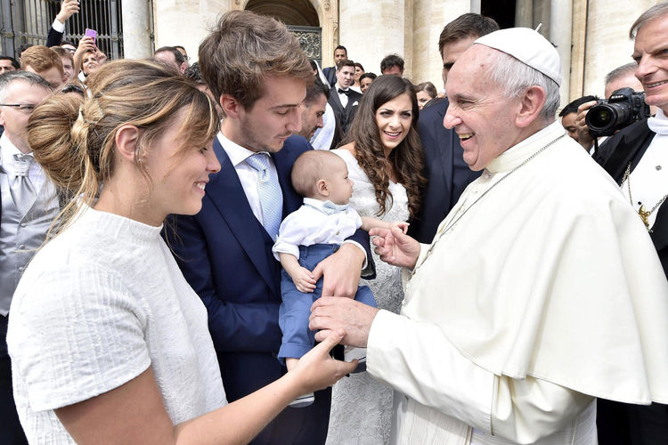
Continuing the second stage of this year’s formation programme in the footsteps of Pope Francis’s Amoris Laetitia, we cannot fail to remember and must always keep in mind the pastoral style witnessed and recommended by the pope.
At the heart of this style, right from the beginning of Pope Francis' pontificate, there are three attitudes, all aimed at ensuring the evangelical quality of witness and proclamation, its character of good news: the note of joy, missionary openness, and a merciful heart.

As for the theme of the family, in the first stage of our journey, recalling Sacred Scripture, the pope recommended that we always hold together the ideal and the reality, that is, the family according to the heart of God and the wounded family of the human heart. On this point, in the second chapter of Amoris Laetitia, dedicated to the current conditions and challenges inherent in the family, the Pope first of all encourages us to seek the hand of God and the depths of his mystery, allowing ourselves to be challenged by the concrete circumstances of family life:

We do well to focus on concrete realities, since “the call and the demands of the Spirit resound in the events of history”, and through these “the Church can also be guided to a more profound understanding of the inexhaustible mystery of marriage and the family”. AL 31

And then it is fundamental, and this is repeated several times, that we should not stop at the diagnosis of the present evils, but we should proceed with possible remedies:
No union that is temporary or closed to the transmission of life can ensure the future of society. But nowadays who is making an effort to strengthen marriages, to help married couples overcome their problems, to assist them in the work of raising children and, in general, to encourage the stability of the marriage bond? AL 52

The family vocation in the light of the youth mission

As we saw in the first stage of our programme, the source and guarantee of family love and fruitfulness lies in the cultivation of the points of intimacy with Jesus and one’s spouse. Its concrete form and its destination - in the Salesian Family as in every family - are the points of fruitfulness, that is, the mission to the young. It is good therefore to share in the Salesian Family and in every family the heart of Don Bosco's charism: the predilection for the young. It is clear that love must extend to everyone, even strangers and enemies, but there is a love of predilection for children, and more generally for the little ones and the poor.

This predilection for the little ones is present in the words of Jesus, it is in the nature of things, and it is in the heart of God: (1) In the Trinity, the intimacy of love between the Father and the Son is the Spirit, whom medieval theologians called the Co-beloved. (2) In the Church the nuptial intimacy between Christ the bridegroom and the Church as bride is expressed in the preferential option for the poor. (3) In the Salesian Family intimacy with the Lord becomes a preference for young people. In the natural family, the intimacy of love between the spouses becomes such an intense love for the children that it often turns out to be excessive. Here we cite a beautiful passage from the Identity Card of the Salesian Family:

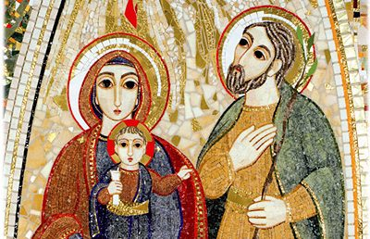
The disciples of Don Bosco cultivate a genuine predilection for the young and devote themselves to the working classes. They are convinced that they have an experience of God precisely through those to whom they are sent, young people and the ordinary people, in particular the poor. Boys and girls are recognised as a gift from God to the Salesian Family; they are the field shown to Don Bosco by the Lord and by Mary in which to carry out his work; for all of us they are the objects of the Salesian vocation and mission (Art 31)

This predilection for young people is not only a matter of sentiment but consists of concrete attitudes. These are, in Don Bosco's language, unconditional acceptance, willingness to spend time with the young, and the desire for their salvation. Predilection for the young means
meeting them at the point in which they are in their process of maturing, but not just to be in their company but rather to lead them to where they are called; for this reason, the educators recognise the power for good the young have within them and support them in the growing pains both human and Christian, identifying with them and for them possible educational opportunities. (Art 31)

These attitudes require specific attention and vigilance: (1)."Unconditional acceptance" means taking young people as they are and not as they should be and having a real aptitude for offering them gradual growth paths. (2). “Willingness to spend time with the young” means being present affectively and effectively, knowing the things they like so that they will appreciate the things that we like, doing things not only for them but with them.
(3). "Desire for their salvation" means being convinced that without Jesus we can do nothing, that without charity everything is in vain, and that care for their well-being includes care for their salvation, because the goods of this world have value only in so far as they point to the goods of heaven.

Youth mission and care for the family vocation
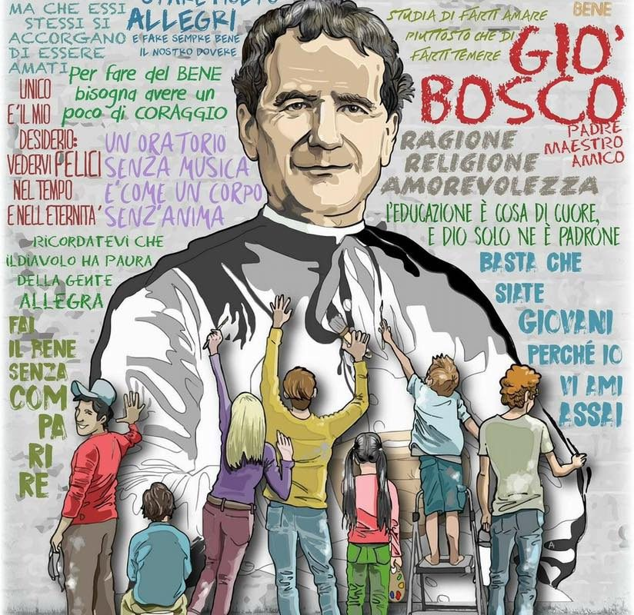
It is precisely our reflection on the pre-dilection for young people that leads us this year, on the recommendation of the Pope, to reflect on the good of the family - for people, for society and for the Church. In fact, in the family, which is a system of relationships made up of a continuous inter-change between genders and gene-rations, there is a precise reciprocity: the family is all for the children, and children need a family. In the language of the ecclesial and Salesian magisterium it is expressed as follows: profound unity of youth ministry and family ministry. This is a decisive point today. In Don Bosco's time, young people and their families were threatened by many forms of poverty, but at least the family was culturally recognized. Today, however, it is not only the salvation of young people that is threatened, but also the salvation of the family itself as an institution naturally destined for their generation and education.

This reciprocity between the two axes of the family - the love of the spouses and the love for their children – can be seen in the life and in the spiritual experience of Don Bosco. The great father of youth lost his own father at an early age. Knowing full well what it means to live in a family without a father, he offered a family with many fathers to groups of young people. As always, it is the logic of the resurrection: life that is born from death, a wound that becomes a means of growth. And it is true for everyone: God writes the pages of his plan of love in our lives, with all our gifts and our limitations, with our history of grace and sin, forming us through wounds and healing, desolation and consolation, through the things he gives us and the things he takes away from us.

Let's listen to what the Rector Major said in 2017 in his beautiful letter on the family:

He lost his father when he was still a child; his mother, Margherita, was his first and decisive educator. We also know well that Don Bosco was what he was because he had the mother he had (§ 3.2).

The loss of his father was a very severe blow:
(What folows is taken from a work by Prof. Juan José Bartolomé, an intervention on the family prepared for the Salesian Family Days in January 2006. The work has not been published. The content of what I write here is largely inspired by that work.)

“I was not yet two years old, when God in his mercy struck us with a grave misfortune. My beloved father, in full vigour and in the prime of life, worked very hard to give a Christian education to his children. One day, he came home from work all sweaty and without thinking went to the cold underground cellar. Later that evening as a result of the perspiration, he contracted a violent fever and constipation. All treatment proved useless, and, in a few days, he found himself at death’s door. Armed with all the comforts of religion, recommending trust in God to my mother, he died at the early age of 34, on 12 May 1817. I do not know what became of me in that mournful occurrence; I only remember, and it is the first thing in my life that I remember, that everyone came out of the deceased's room, and I absolutely wanted to stay there. - Come, Giovanni, come with me, said my sorrowful mother. - If father is not coming, I don't want to go, I replied. My poor son, my mother repeated, come with me, you no longer have a father."

It is from these events and feelings (the death of his father Francesco, the hostility of his elder brother, the death of Don Calosso) that Don Bosco developed the heart of a father, teacher and friend of the young: from the acute sense of the lack of a father and from the acute sense of God’s fatherliness and providence taught by two mothers, Mamma Margaret and Mary Help of Christians.

If this is so, then it is necessary to make every effort to protect and promote the family as the first condition for the education of the new generation. The protection and promotion of the family is so important that the "family spirit" is one of the distinctive features of Don Bosco's charism. And in fact, the Strenna of 2017, after recalling Don Bosco's experience regarding the figure of the father, continues precisely by recalling the duty to realize in practice what the family is called to be, and to prevent it from becoming the opposite, and that is, that from a generative place it becomes degenerative, and that from a place of growth it becomes a place that compromises growth. Here the Rector Major's point of reference is precisely the second chapter of Amoris Laetitia. Let's go and consult it, starting with a very precise statement:
No one can think that the weakening of the family as that natural society founded on marriage will prove beneficial to society as a whole. The contrary is true: it poses a threat to the mature growth of individuals, the cultivation of community values and the moral progress of cities and countries. There is a failure to realize that only the exclusive and indissoluble union between a man and a woman has a plenary role to play in society as a stable commitment that bears fruit in new life… No union that is temporary or closed to the transmission of life can ensure the future of society. (AL 52)

The reality and the challenges facing the family
The pope presents the current situation of the family with great intellectual and pastoral finesse. He first of all points out that some achievements in themselves positive are not lacking in ambiguity, since greater freedom is accompanied by greater fragility:

Today the Church recognizes a domestic reality with greater spaces of freedom, "with an equitable distribution of duties, responsibilities and tasks ... but individuals in personal and family life, receive less and less support from social structures than in the past.” (AL 32)

The achievement of parity between men and women and the better distribution of family tasks is vitiated by the individualistic mentality that runs through it, producing a sort of jealousy for the freedom that sooner or later leads to conflict in the family, and which places the family simply at the service of the individual:
“Equal consideration needs to be given to the growing danger represented by an extreme individualism which weakens family bonds and ends up considering each member of the family as an isolated unit, leading in some cases to the idea that one’s personality is shaped by his or her desires, which are considered absolute… The tensions created by an overly individualistic culture, caught up with possessions and pleasures, leads to intolerance and hostility in families… constant suspicion, fear of commitment, self-centredness and arrogance.“ (AL 33)
When these factors affect our understanding of the family, it can come to be seen as a way station, helpful when convenient, or a setting in which rights can be asserted while relationships are left to the changing winds of personal desire and circumstances. (AL34)
There is another feature of our time that heavily affects family ties, by their nature oriented towards the promotion of novelty through stability. This is what the Pope calls the culture of the ephemeral:

Here I think, for example, of the speed with which people move from one affective relationship to another. They believe, along the lines of social networks, that love can be connected or disconnected at the whim of the consumer, and the relationship quickly “blocked”. I think too of the fears associated with permanent commitment, the obsession with free time, and those relationships that weigh costs and benefits for the sake of remedying loneliness, providing protection, or offering some service. We treat affective relationships the way we treat material objects and the environment: everything is disposable; everyone uses and throws away, takes, and breaks, exploits and squeezes to the last drop. Then, goodbye. ... Marital problems are “often confronted in haste and without the courage to have patience and reflect, to make sacrifices and to forgive one another.” (AL 39.41)

Among the wounds that hurt the family, and people and society, there is a widespread anti-birth culture. It is known that the so-called "demographic winter" is now the number one problem of Western societies, and with the risk of worldwide extension:
The decline in population, due to a mentality against having children and promoted by the world politics of reproductive health, creates not only a situation in which the relationship between generations is no longer ensured but also the danger that, over time, this decline will lead to economic impoverishment and a loss of hope in the future. (AL 42)

Meanwhile, forms of poverty persist that have always existed, and that today take on a form that has always afflicted - and today in a particular way - the family, insofar as it requires and offers stability. Among the many forms of family instability, the Pope mentions three in particular: precarious housing, migratory phenomena, children born out of wedlock. Let's listen to some passages:
The lack of dignified or affordable housing often leads to the postponement of formal relationships. It should be kept in mind that “the family has the right to decent housing, fitting for family life and commensurate to the number of the members, in a physical environment that provides the basic services for the life of the family and the community”. Families and homes go together. This makes us see how important it is to insist on the rights of the family and not only those of individuals. The family is a good which society cannot do without, and it ought to be protected. (AL 44)
“A great number of children are born outside of wedlock, many of whom subsequently grow up with just one of their parents or in a blended or reconstituted family… We see the serious effects of this breakdown in families torn apart, the young uprooted and the elderly abandoned, children who are orphans of living parents, adolescents and young adults confused and unsupported.” (AL 45.51)
“Migration is another sign of the times to be faced and understood in terms of its negative effects of family life... Migration is particularly dramatic and devastating to families and individuals when it takes place illegally and is supported by international networks of human trafficking. (AL 46)
The pope is particularly severe with the prevailing phenomenon of genderism, as it represents a real contestation of the order of creation and assumes ideological positions that cause us to lose contact with reality and the primordial evidence of life:
Yet another challenge is posed by the various forms of an ideology of gender that “denies the difference and reciprocity in nature of a man and a woman and envisages a society without sexual differences, thereby eliminating the anthropological basis of the family. This ideology leads to educational programmes and legislative enactments that promote a personal identity and emotional intimacy radically separated from the biological difference between male and female. Consequently, human identity becomes the choice of the individual, one which can also change over time”. It is a source of concern that some ideologies of this sort, which seek to respond to what are at times understandable aspirations, manage to assert themselves as absolute and unquestionable, even dictating how children should be raised. It needs to be emphasized that “biological sex and the socio-cultural role of sex (gender) can be distinguished but not separated” (AL 56)
Finally, family crises have at their root the crisis of faith. Maybe today there is a lot of spirituality, but little religion, a lot of idealism but little practicality:

The weakening of faith and religious practice in some societies has an effect on families, leaving them more isolated amid their difficulties. The Synod Fathers noted that “one symptom of the great poverty of contemporary culture is loneliness, arising from the absence of God in a person’s life and the fragility of relationships. (AL 43)

The ecclesial responsibilities, however, are not to be overlooked, for example, a proclamation of the Gospel that is not very evangelical, and an imbalanced presentation of marriage that lays emphasis more on procreation than on love, more on the law than on grace, more on morality than on faith:
As Christians, we can hardly stop advocating marriage simply to avoid countering contemporary sensibilities, or out of a desire to be fashionable or a sense of helplessness in the face of human and moral failings... What we need is a more responsible and generous effort to present the reasons and motivations for choosing marriage and the family, and in this way to help men and women better to respond to the grace that God offers them.

We also need to be humble and realistic, acknowledging that at times the way we present our Christian beliefs and treat other people has helped contribute to today’s problematic situation. We need a healthy dose of self-criticism... Then too, we often present marriage in such a way that its unitive meaning, its call to grow in love and its ideal of mutual assistance are overshadowed by an almost exclusive insistence on the duty of procreation. Nor have we always provided solid guidance to young married couples, understanding their timetables, their way of thinking and their concrete concerns.

We have long thought that simply by stressing doctrinal, bioethical and moral issues, without encouraging openness to grace, we were providing sufficient support to families, strengthening the marriage bond and giving meaning to marital life. (AL 35.36.37)
In practice.
This month we will commit ourselves to living and witnessing, savouring and helping others to savour, the values of faithful and fruitful, intimate and social, affectionate and generous family ties, avoiding all the closures, rigidities and judgments that are contrary to the family as a place of maturation in freedom and love.
GETTING TO KNOW EACH OTHER

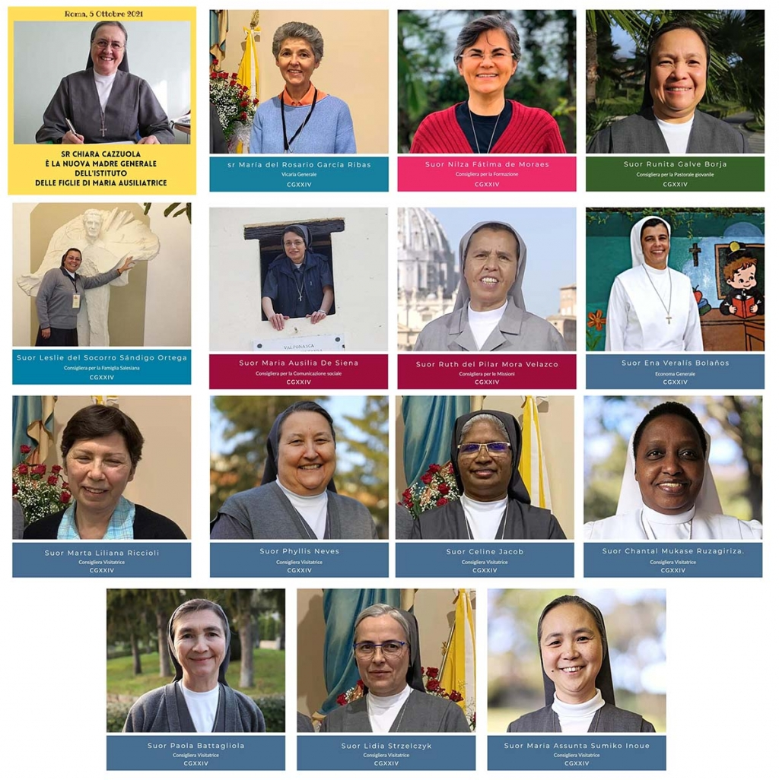
In this month of October, we want to introduce the members of the new FMA General Council who were elected GC XXIV. They are:

We thank the Lord for their willingness in accepting this new service. We accompany their ministry with our prayers, and we entrust them to Don Bosco’s Madonna that they may be living monuments of our Mother, the Help of Christians, according to the spirit of our founding father and Mother Mazzarello.
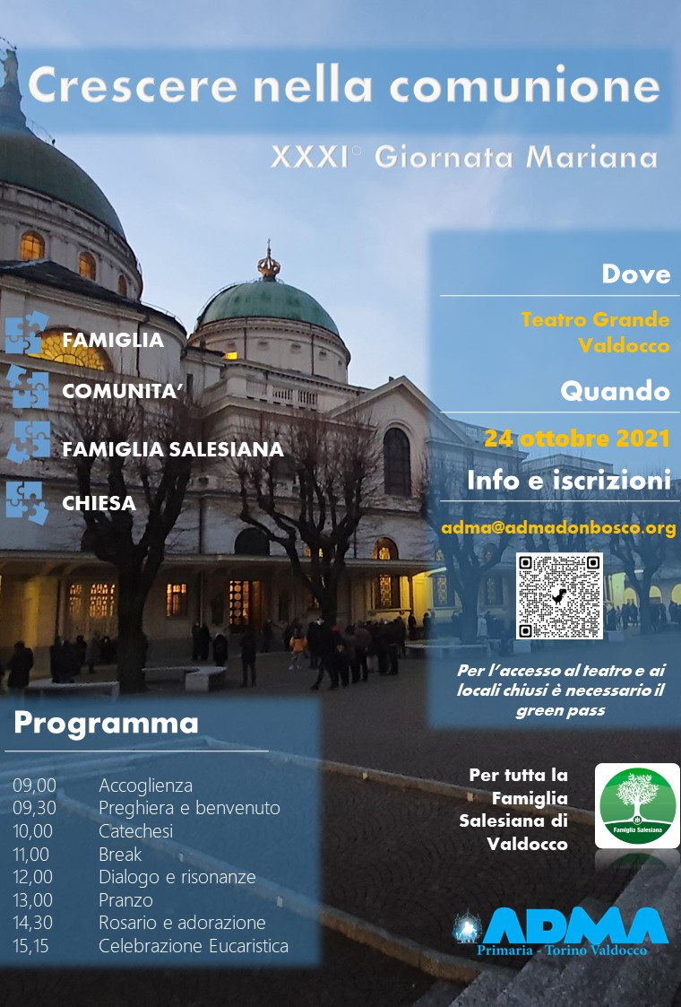
We include the programme of the Giornata Maria at Valdocco to ask for your prayers. The elections for the new Primary ADMA Council – Valdocco will be held on that day.

REGULATIONS

REGULATIONS OF THE ASSOCIATION OF MARY HELP OF CHRISTIANS

FOR STUDY AND IMPLEMENTATION

TO HELP US TO REALIZE OUR IDENTITY

ARTICLE 4 - Personal commitment of the members (THIRD PART)

Mary invites us to fidelity in prayer and apostolic action. She exhorts us to work for the salvation of all, especially the young and the poor.
Due to its popular character and its great diffusion, our Association can be considered the "gateway to the Salesian Family", a fertile ground where Vocations can mature.
We grasp the beauty of daily life, living like Mary and making her attitudes our own.
Her FIAT as a docile abandonment to the will of the Father. Mary is with us and prays to the Holy Spirit to guide us on the path to holiness.

Her STABAT, resilience and perseverance even in the most difficult trials. Mary walks with us, supports us, raises us up when we fall and leads us to Jesus.

Her MAGNIFICAT as a prayer of thanks for the gifts we receive. Mary desires our happiness, and we draw inspiration from her in our spiritual life.

Virgin ever attentive, help us to treasure the Word of God and to live it with daily fidelity.
Virgin ever at prayer, pray with us to the Father with simplicity and gratitude.
Virgin Mother, grant that we always remain united with the Pope and the Church. Virgin ever obedient, help us to make our lives an offering to God in obedience to his will.

"Only those who believe in the unlimited power of the Help of Christians will entrust themselves to her protection, not only by words spoken on their lips, but with an intimate and powerful act of dedication. And whoever is under the protection of Mary is well guarded.” (Edith Stein - Saint Teresa Benedicta of the Cross).
Andrea and Maria Adele Damiani

FAMILY CHRONICLE

- https://www.infoans.org/sezioni/foto-notizie/item/13743-pakistan-nasce-a-quetta-un-gruppo-dell-adma

- https://www.infoans.org/sezioni/foto-notizie/item/13727-angola-nuovo-gruppo-dell-adma-a-huambo

- https://www.infoans.org/sezioni/notizie/item/13688-italia-l-adma-primaria-riparte-dal-colle-don-bosco-presentato-il-cammino-formativo-dell-anno

- https://www.infoans.org/sezioni-eventi/item/13634-rmg-ii-congresso-dell-adma-nella-regione-asia-est-oceania-una-ricca-esperienza-carismatica

